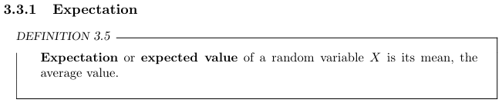
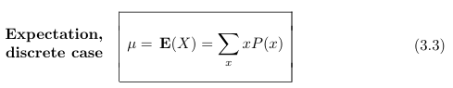
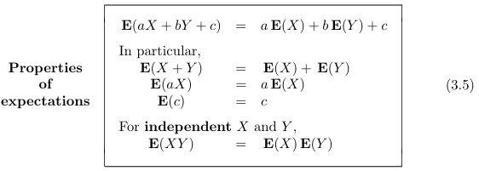
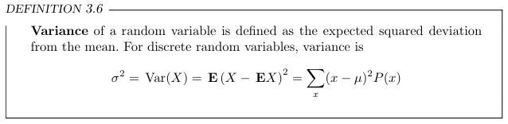
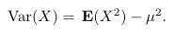
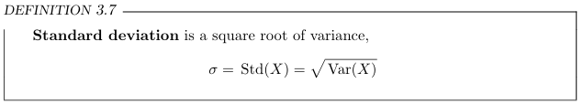

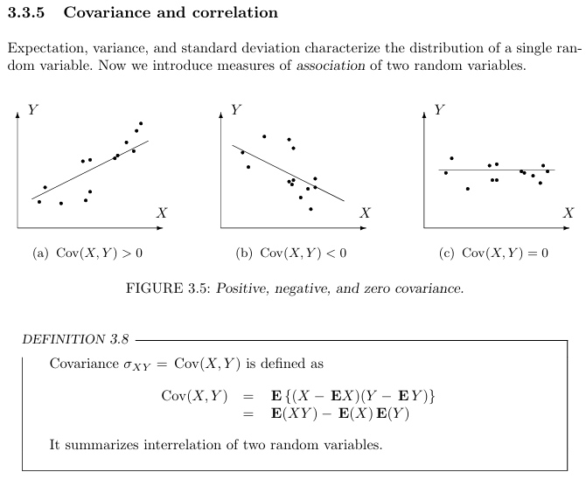
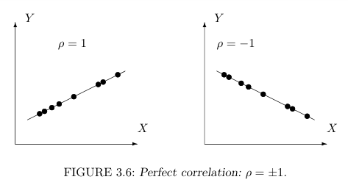
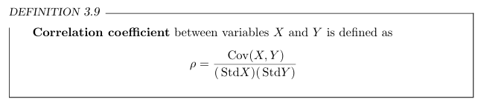
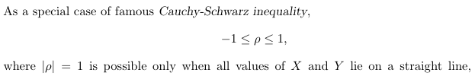

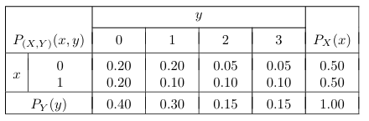
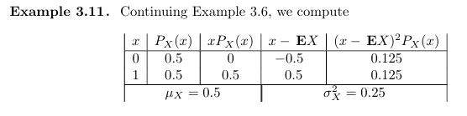

E(X)= 0 (0.5) +1(0.5) = 0.5



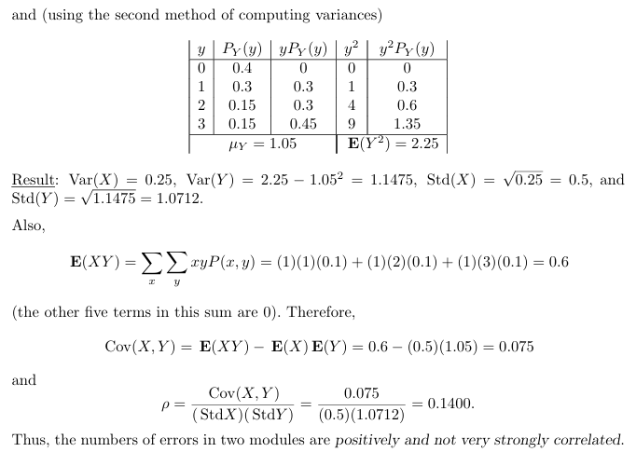
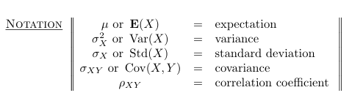

3.2. Every day, the number of network blackouts has a distribution (probability mass function) x 0 1 2 P(x) 0.7 0.2 0.1 Discrete Random Variables and Their Distributions 69 A small internet trading company estimates that each network blackout results in a $500 loss. Compute expectation and variance of this company’s daily loss due to blackouts.

Solution:
x | 0 | 1 | 2
P(x) | 0.7 | 0.2 | 0.1

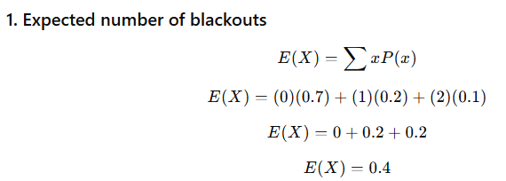
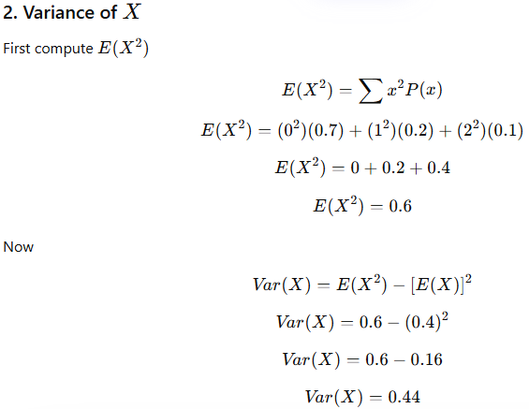
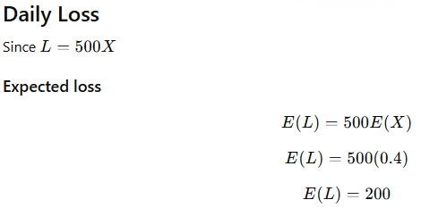
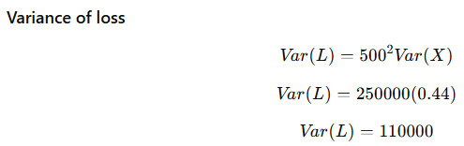
3.7. The number of home runs scored by a certain team in one baseball game is a random variable with the distribution x 0 1 2 P(x) 0.4 0.4 0.2 The team plays 2 games. The number of home runs scored in one game is independent of the number of home runs in the other game. Let Y be the total number of home runs. Find E(Y) and Var(Y).

Solution:
x | 0 | 1 | 2
P(x) | 0.4 | 0.4 | 0.2

The team plays 2 independent games.
Let Y=X1+X2 ​ be the total number of home runs in two games.

